Identity Fraud (2.5)

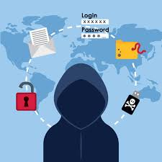

In this section we will answer:

- How am I at risk for identity fraud?

- What should I do if I’m a victim of identify fraud?

- How can I protect my personal information?

What’s in your wallet?

You are going to go on a financial scavenger hunt. You have three minutes to find these items in their wallets, backpacks, purses, or pockets. Take a look and see how many of the items listed they currently have in your possession. Give yourself one point for every item you currently have in your position

__ Credit card (The actual number of cards)

__ ID card with photo (school, employment)

__ $5 bill

__ Change (coins) totaling $2 or more

__ Original Social Security card

__ Picture of a close relative

__ Computer password (The actual number of passwords)

__ Bank/Credit Union ATM PIN number

__ Library card

__ Paycheck stub

__ Bank or credit union deposit slip

__ Any type of money-saving coupon

__ Car keys

__ Flash drive for computer

__ Cell phone

__ Driver’s license

__ Facial tissue

__ Membership card

__ Food

Total Points:

A case of mis-taken identity

ASSIGNMENT

Search online to find the answers to the following questions (don’t forget to cite your sources):

- What percentage of identity fraud crimes were committed by someone the victim knew?

- What are the five most common types of identity theft?

RESOURCES:

- FBI, “Identify Fraud,“ www.fbi.gov/scams-safety/fraud/fraud#id

- Credit Card Fraud,” FBI Internet Crime Complaint Center, www.ic3.gov/media/annualreports.aspx

- Federal Trade Commission’s Identify Fraud site, www.ftc.gov/bcp/edu/microsites/idtheft

- Identity Theft Resource Center, www.idtheftcenter.org

- Identity Theft Teen Space, www.idtheftcenter.org/teen/teen- sheila.html

- Child Identity Theft: New Evidence Indicates Identity Thieves are Targeting Children for Unused Social Security Numbers, Richard Power, Carnegie Mellon, 2011

- 2011 Child Identity Fraud Study, ID: Analytics whitepaper

Triple D approach to fraud

Keep it to yourself

Activity 2.10: Take preventive action

Directions:

- For each of the suggestions, evaluate what you do now to deter thieves from stealing your personal information.

- To the left of each bullet, write your rating as “+” if the advice matches your actions most of the time, “-“if you never carry out the action, or “+/-“ if you sometimes do the action but could be more careful.

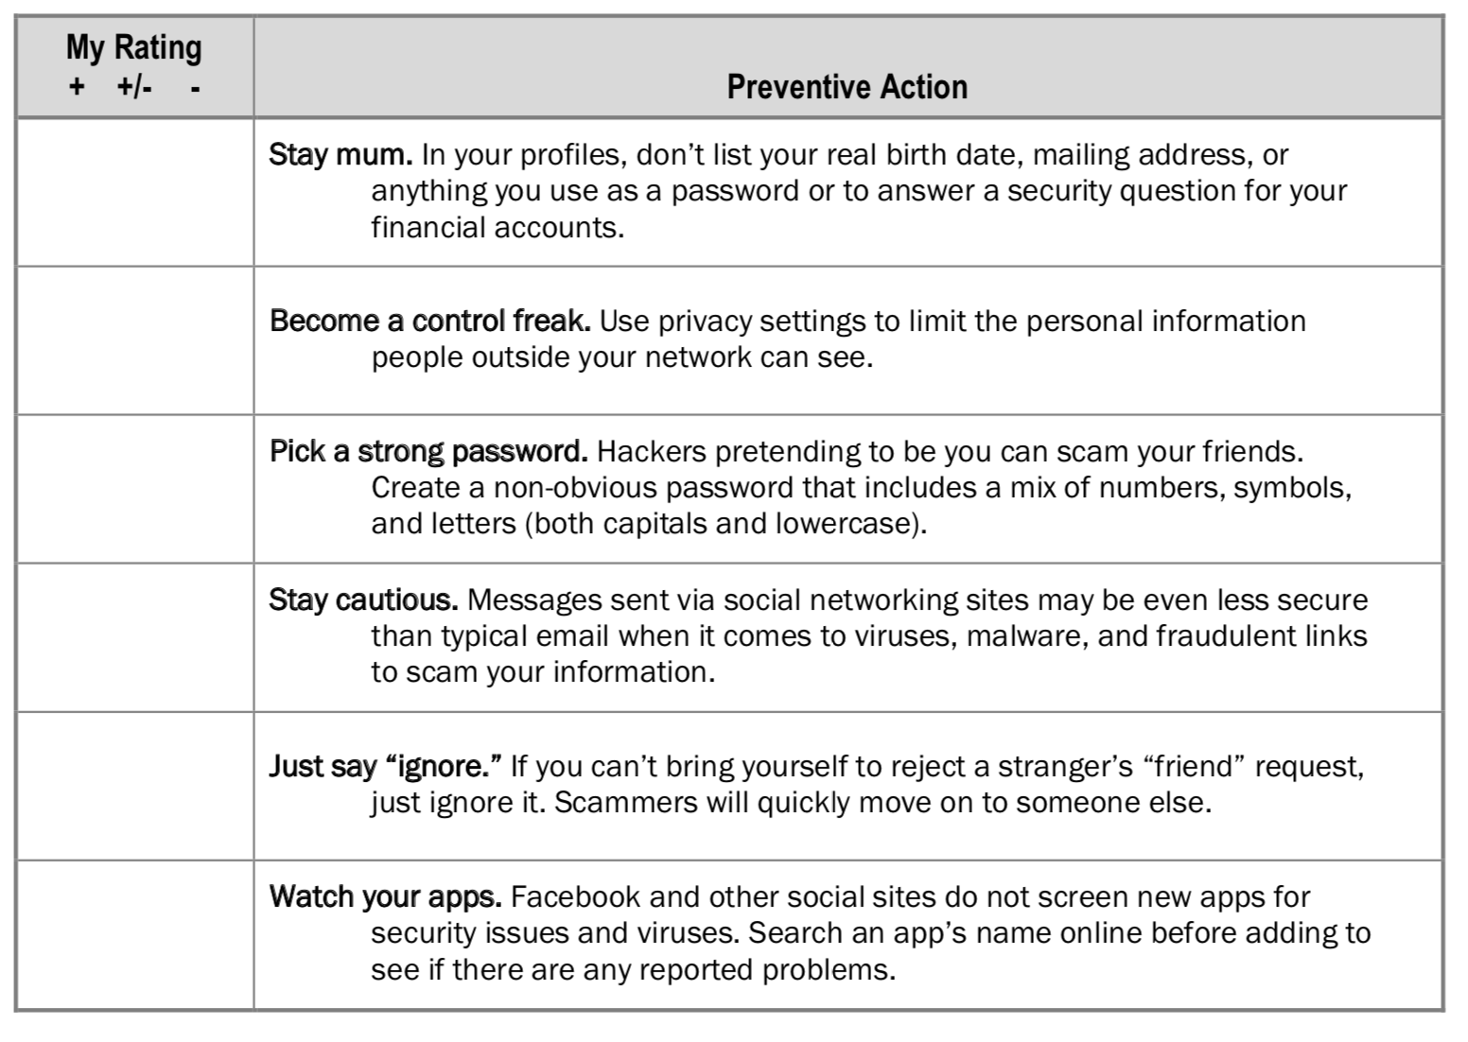

Action Plan for Fraud

